**SonarQube**

|  |  |  |  |  |
| --- | --- | --- | --- | --- |
| **S.No.** | **Author** | **Created Date** | **Reviewer** | **Reviewed Date** |
| 1 | Rajesh Ponnakatti  (rajesh.ponnakatti@sap.com) | 7-Aug-2015 | Deepti | 13-Aug-2015 |

Table of Contents

What is SonarQube? 3

Steps to configure SonarQube locally and execute the sonar scan using command Prompt: 3

Steps to scan code using SonarQube plugin in Eclipse IDE: 6

Issues faced while installing 9

Most Commonly found issues During SonarQube Scan and the fixes: 9

# What is SonarQube?

SonarQube is an open source Platform used by development teams to manage source code quality. Main objective of SonarQube is to make code quality management accessible to everyone with minimal effort.

# Steps to configure SonarQube locally and execute the sonar scan using command Prompt:

1. Download the SonarQube from server ss<http://dist.sonar.codehaus.org/sonar-4.5.1.zip>
2. Extract the zip folder to C drive and navigate to the extracted path.(e.g.: C:\Users\c5228096\sonar-3.7.4\bin\windows-x86-643.7.4.zip)
3. Run StartSonar.bat file

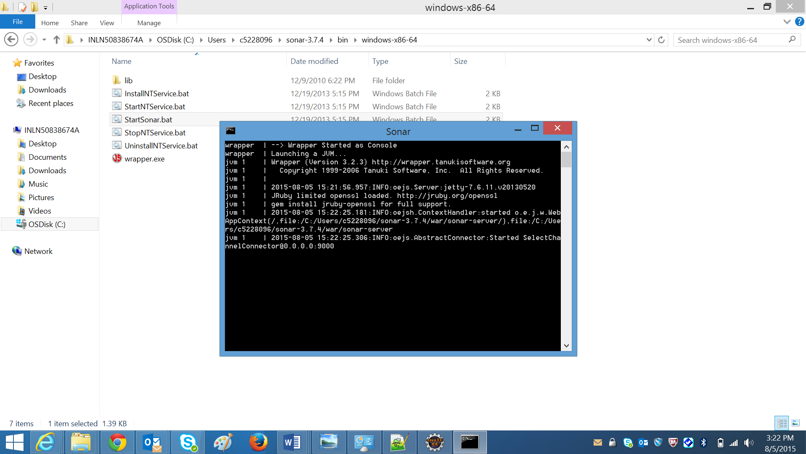

1. Open the url: <http://localhost:9000> in browser and login using the default user id and password provided (UserID/Password: abc/xyz)

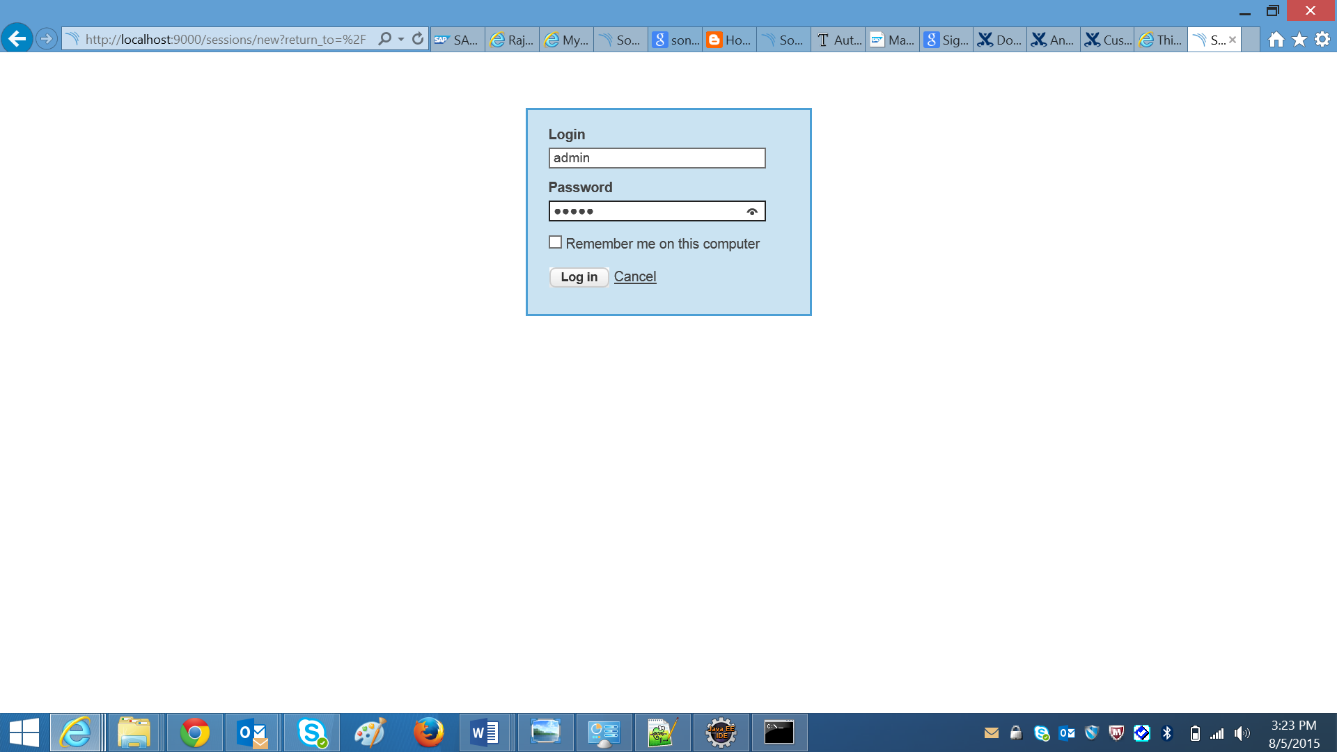

1. Click on Quality Profiles.

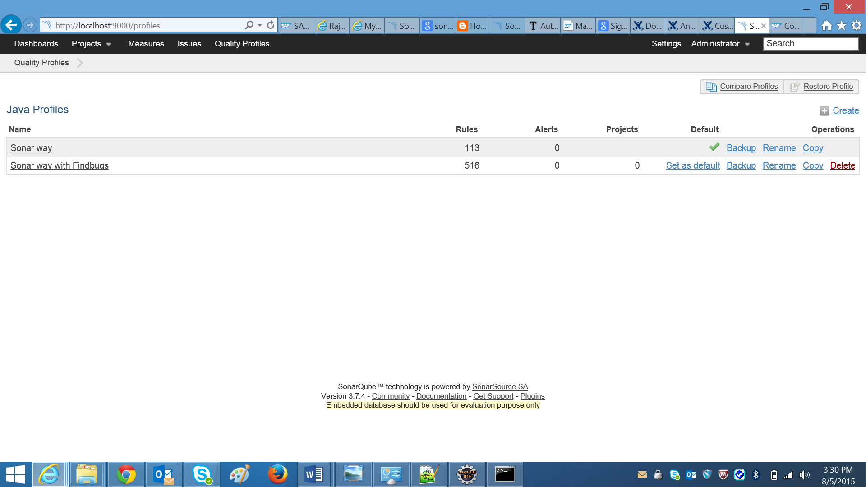

1. Click on Restore Profile button (It is towards right side of the screen). In the Restore Profile dialogue box choose sonar.xml file and click on Restore button (Note: Ignore if there are any warnings in the next screen)

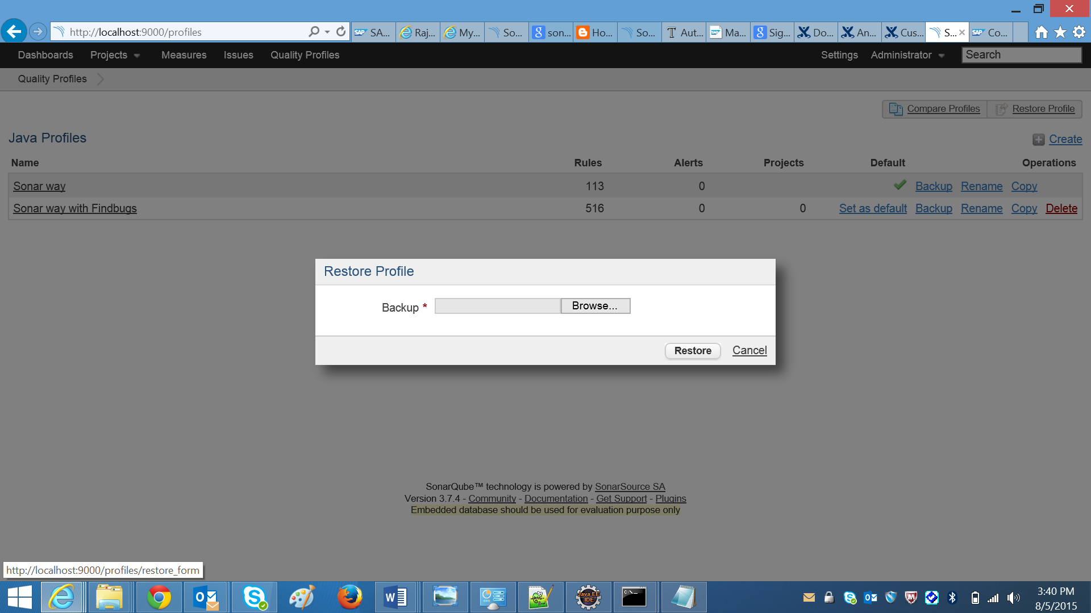

The xml file to be selected:ss



1. Click on set as default link for SAPDefaultProfile_1_4_2.
2. Navigate to maven “settings.xml” file and modify sonar configuration.

**Note:** s

* Path to settings.xml (e.g.: C:\Users\i064085\.m2\settings.xml)
* Comment the below properties section and replace the properties section

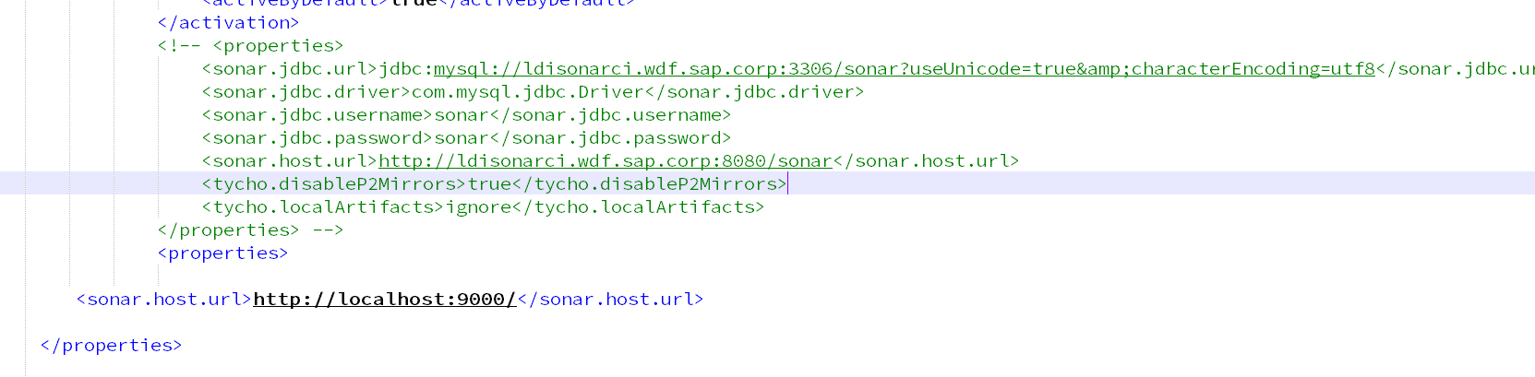

* Update the below in properties section

<properties>

<sonar.host.url>http://localhost:9000/</sonar.host.url>

</properties>

1. Navigate to the root folder of your project in command prompt and run the following command

mvn sonar:sonar: -Dexternal.build=X

Wait for the build to succeed.

1. Once the build succeeds, SonarQube scan result can be seen in the dashboard of url http://localhost:9000/

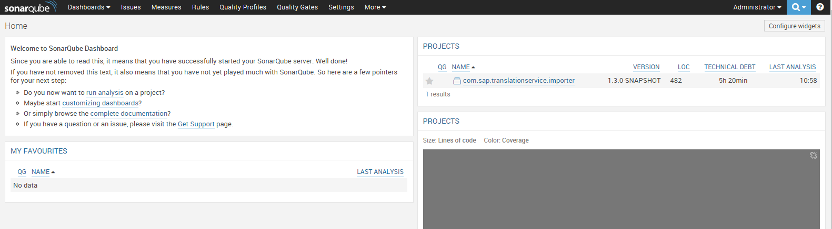

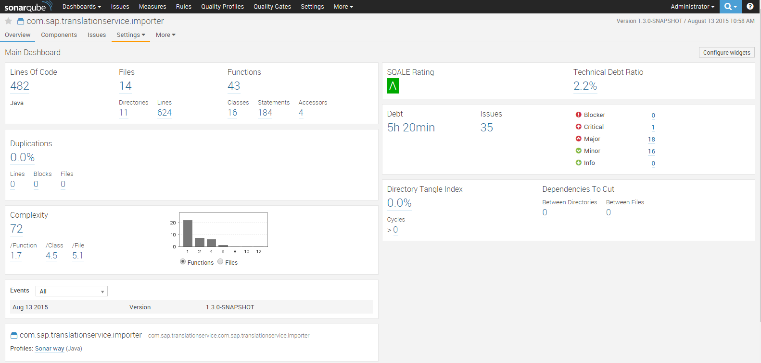

1. Click on Issues and double click on the issue. It gives the details of the issue.

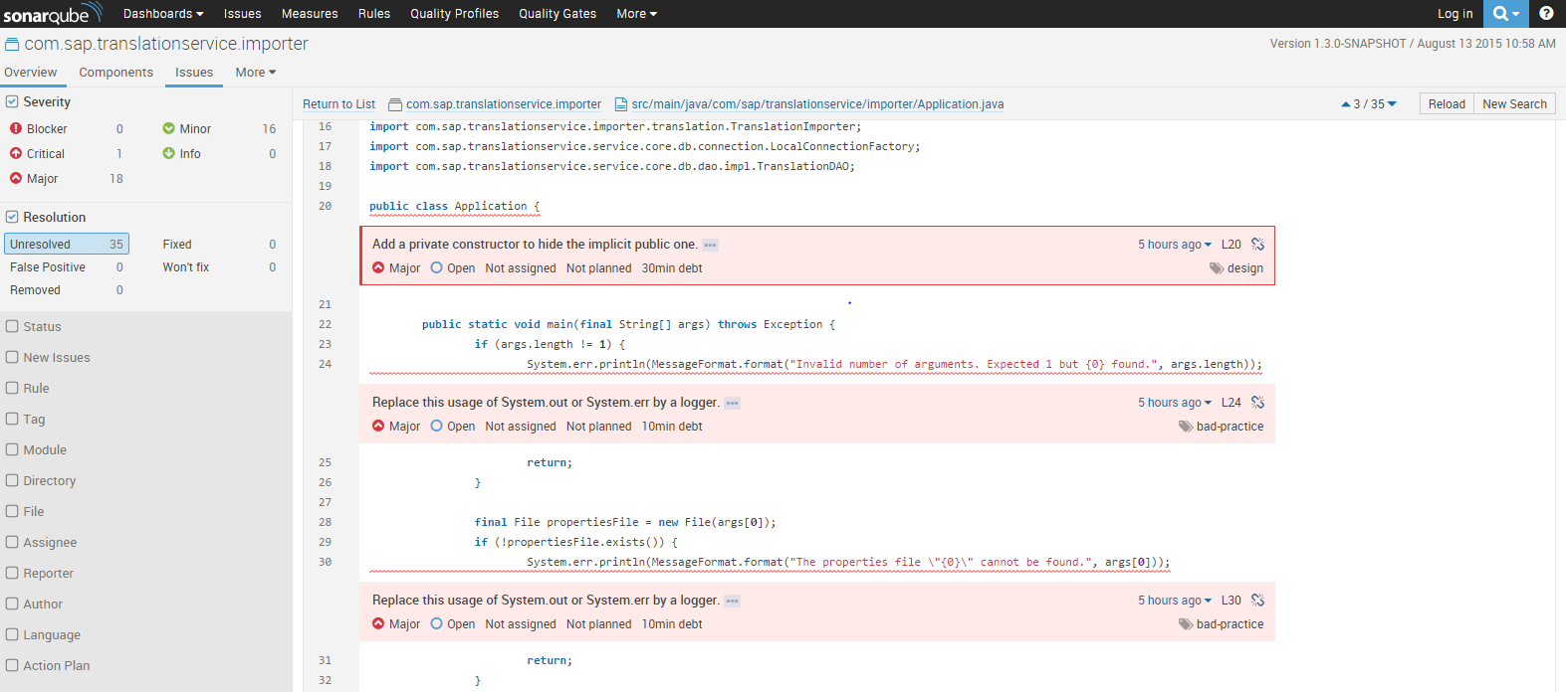

1. The above issue can be fixed in eclipse by using logger instead system.out.print

------------------------

Sonar plugins details:

-----------------------

Download the below Plugins:

<http://nexus.wdf.sap.corp:8081/nexus/content/groups/build.releases/org/codehaus/sonar-plugins/java/sonar-java-plugin/2.6/sonar-java-plugin-2.6.jar>

<http://nexus.wdf.sap.corp:8081/nexus/content/groups/build.releases/com/sap/ldi/sonar-mqr-plugin/1.13.0/sonar-mqr-plugin-1.13.0.jar>

<http://nexus.wdf.sap.corp:8081/nexus/content/groups/build.milestones/com/sap/ui5/tools/sonar/sonar-javascript-plugin/0.14.0/sonar-javascript-plugin-0.14.0.jar>

<http://nexus.wdf.sap.corp:8081/nexus/content/groups/build.releases/org/codehaus/sonar-plugins/java/sonar-pmd-plugin/2.3/sonar-pmd-plugin-2.3.jar>

<http://nexus.wdf.sap.corp:8081/nexus/content/groups/build.releases/org/codehaus/sonar-plugins/java/sonar-findbugs-plugin/3.1/sonar-findbugs-plugin-3.1.jar>

<http://nexus.wdf.sap.corp:8081/nexus/content/groups/build.releases/org/codehaus/sonar-plugins/java/sonar-checkstyle-plugin/2.2/sonar-checkstyle-plugin-2.2.jar>

Added the plugins jar below path: C:\Users\c5228096\sonarqube-4.5.1\extensions\plugins

# Steps to scan code using SonarQube plugin in Eclipse IDE:

1. Help🡺Eclipse Marketplace

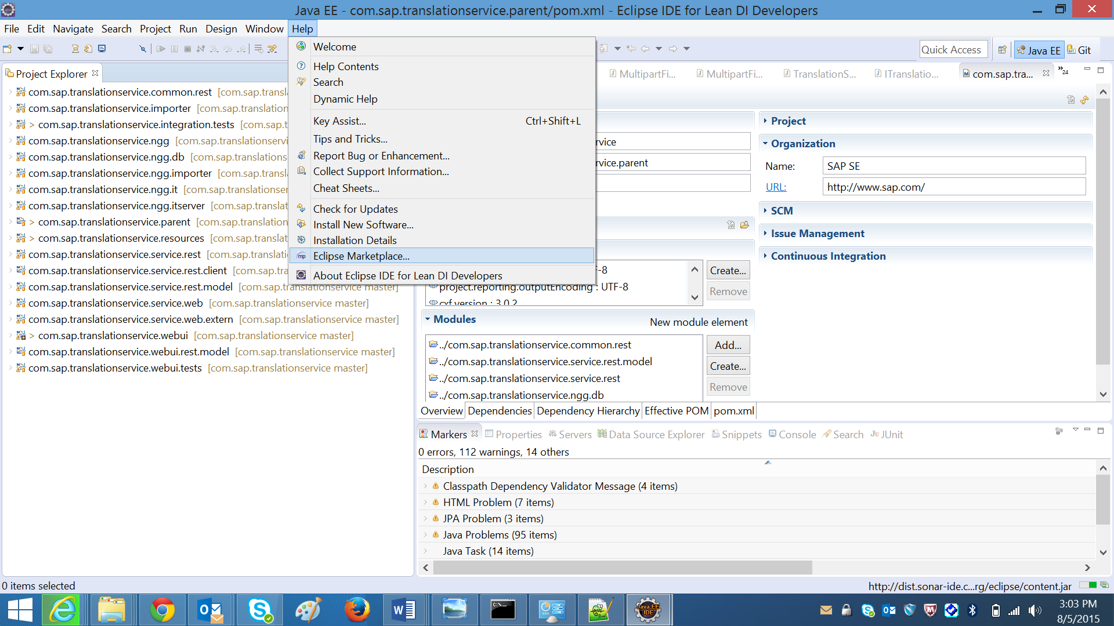

1. Search sonar

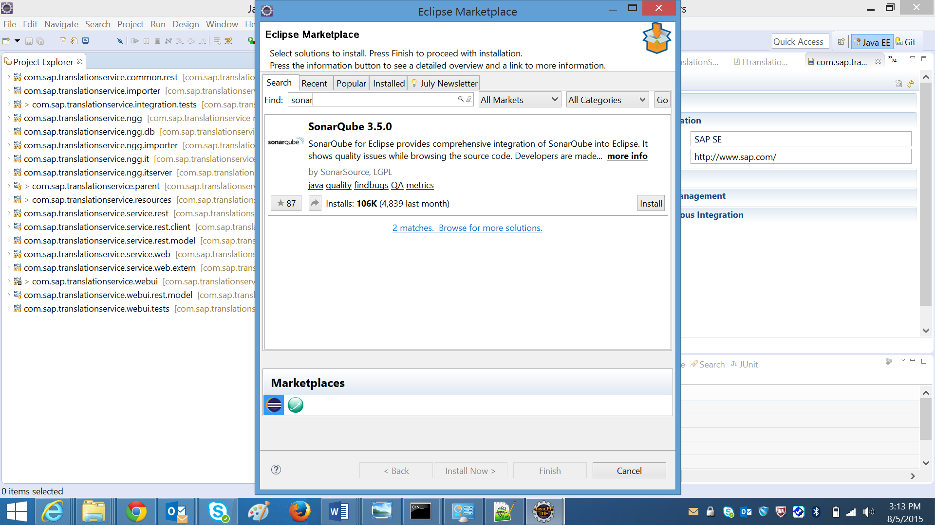

1. Click Install button and select the solutions mentioned in the below picture, to install

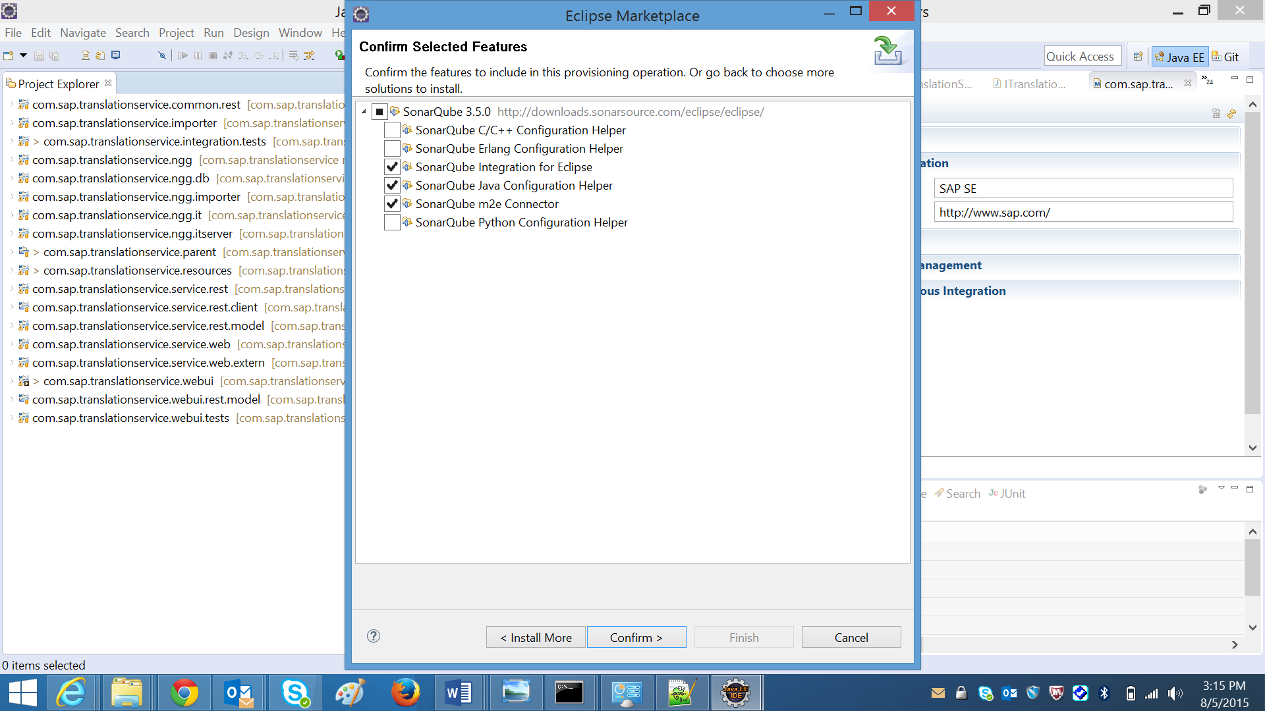

1. Click Confirm

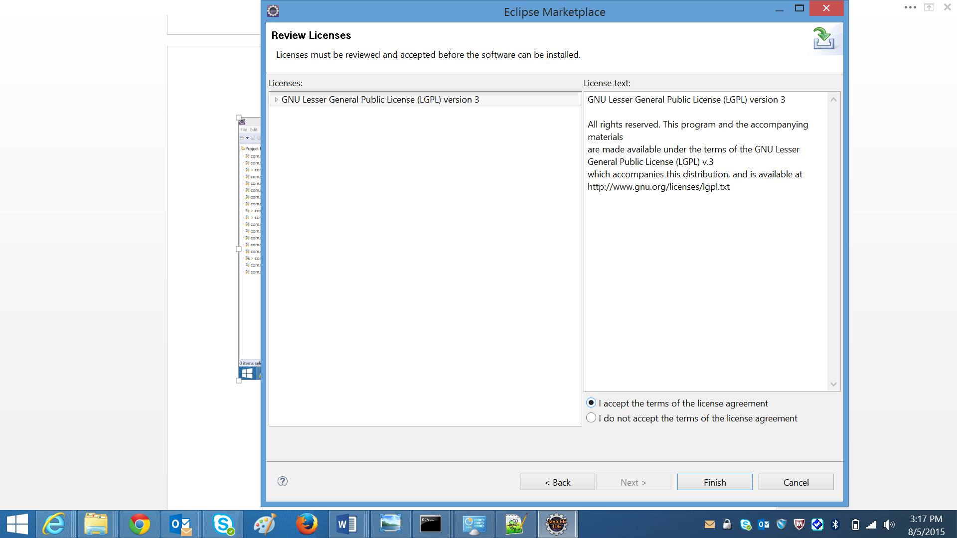

1. Click Finish

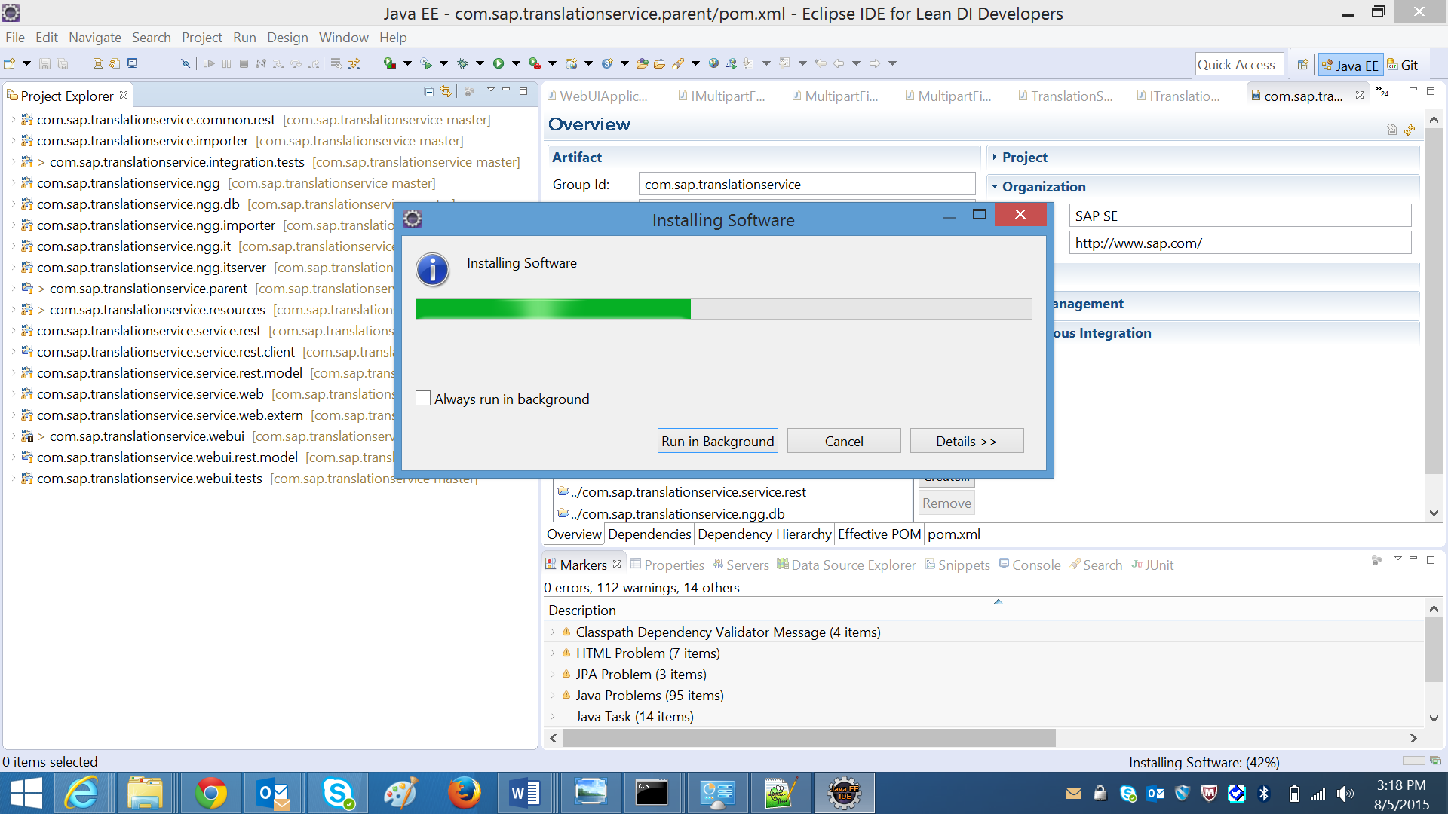

1. Right click on a package which needs to be scanned in the project explorer and click on configure 🡪 Associate with SonarQube
2. Right click on the same package and click on SonarQube 🡪 Analyze
3. Open “sonar issues” view in eclipse to see the results.

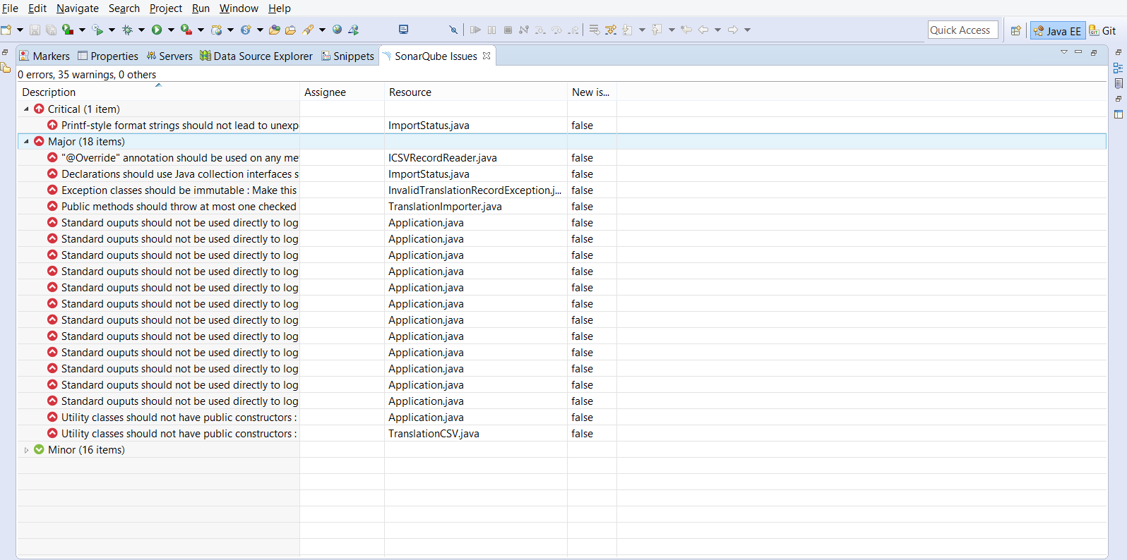

# Issues faced while installing

1. SonarQube was not able to analyze and give the error report

**Resolution:** Re-installed the same and scanned again.

# Most Commonly found issues During SonarQube Scan and the fixes:

1. Unused import

**import** java.io.FileWriter;

**import** java.io.IOException;

**import** java.text.ParseException;

**import** java.text.SimpleDateFormat;

**import** java.util.Calendar;

**import** java.util.Date;

**import** javax.persistence.EntityManager;

**import** javax.persistence.Persistence;

**import** javax.persistence.Query;

**Resolution:** Remove the unused import. In this case remove “import java.util.Date;”

1. Exception handlers is not preserving the original exception

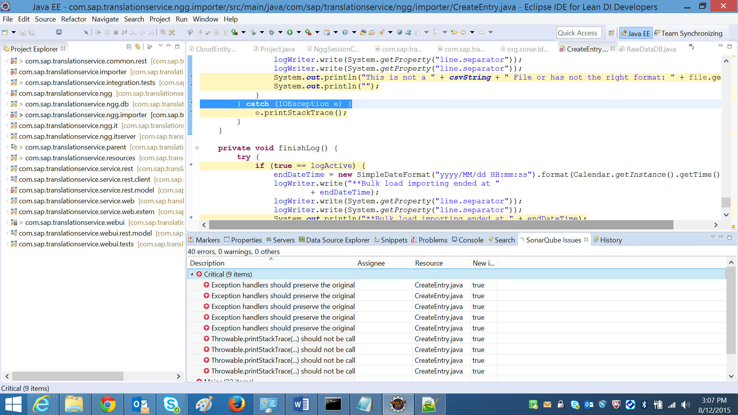

**Resolution:** Either Use Loggers or re-throw the original exception

} **catch** (IOException e) {

**throw** **new** RuntimeException("logActive false");

}

Or

logActive = **false**;

}

} **catch** (IOException e) {

**logger.write(**"logActive false");

}